**IPL TEAMS DATA ANALYSIS**

**A PROJECT REPORT**

***Submitted to***

**SAVEETHA INSTITUTE OF MEDICAL AND TECHNICAL SCIENCES**

***In partial fulfillment for the award of the degree of***

**ITA0389 MOBILE COMPUTING FOR 5G APPLICATION**

***BY,***

***BALAJI RAMPRASAD.K 192124103***



**SAVEETHA SCHOOL OF ENGINEERING**

**SAVEETHA INSTITUTE OF MEDICAL AND TECHNICAL SCIENCE**

**THANDALAM, KANCHIPURAM - CHENNAI RD,**

**CHENNAI 602105**

**MARCH 2025**

**BONAFIDE CERTIFICATE**

Certified that this project report “ENCHANCING HEALTHCARE EXCELLENCE

THROUGH TOTAL QUALITY MANAGEMENT” is the Bonafide work of Balaji Ramprasad.K(192124103) who carried out the project work under my supervisor as a batch. Certified further , that to the best of our knowledge the work reported here in does not form any other project report.

**SIGNATURE**

**Dr K Ramesh kumar**

Project Guide and HoD

Department of Nxt Gen Computing

Saveetha School of Engineering

DATE OF EXAMINATION : ______________________________

INTERNAL EXAMINER EXTERNAL EXAMINER

**ACKNOWLEDGEMENT**

This project work would not have been possible without the contribution of many people. It gives me immense pleasure to express my profound gratitude to our Honorable Chancellor **Dr.N.M.Veeraiyan,** Saveetha Institute of Medical and Technical Sciences, for his blessings and for being a source of inspiration. I sincerely thank our Pro-Chancellor **Dr.Deepak Nallaswamy,** SIMATS, for his visionary thoughts and support. I am indebted to extend my gratitude to our Director **Dr.Ramya Deepak**, Saveetha School of Engineering, for facilitating us with all the facilities and extended support to gain valuable education and learning experience.

I register my special thanks to **Dr.B.Ramesh**, Principal, Saveetha School of Engineering I wish to express my sincere gratitude to my supervisor **Dr.K.Ramesh kumar**, for his inspiring guidance, personal involvement and constant encouragement during the entire course of this work.

I am grateful to Project Coordinators, Review Panel External and Internal Members and the entire faculty of the Department of Automobile Engineering, for their constructive criticisms and valuable suggestions which have been a rich source to improve the quality of this work.

Balaji Ramprasad.k (192124103)

**TABLE OF CONTENT**

|  |  |  |
| --- | --- | --- |
| S.No | NAME | PAGE No |
| 1 | Abstract |  |
| 2 | List of Figures and Tables |  |
| 3 | Acknowledgments |  |
| 4 | Introduction |  |
| 5 | Problem Identification and Analysis |  |
| 6 | Solution Design and Implementation |  |
| 7 | Results and Recommendations |  |
| 8 | Reflection on Learning and Personal Development |  |
| 9 | Conclusion |  |
| 10 | References |  |
| 11 | Appendices |  |

ABSTRACT

This project focuses on visualizing IPL team performance using Tableau. By analyzing key metrics such as wins, losses, points, and net run rate, we aim to provide insightful visualizations that help in understanding team performance over time. The project leverages Tableau’s interactive features to create dashboards for data-driven decision-making.

LIST OF FIGURES AND TABLES

* Bar Chart
* Pie Chart
* Scatter Plot
* Heap Map

BAR CHART:

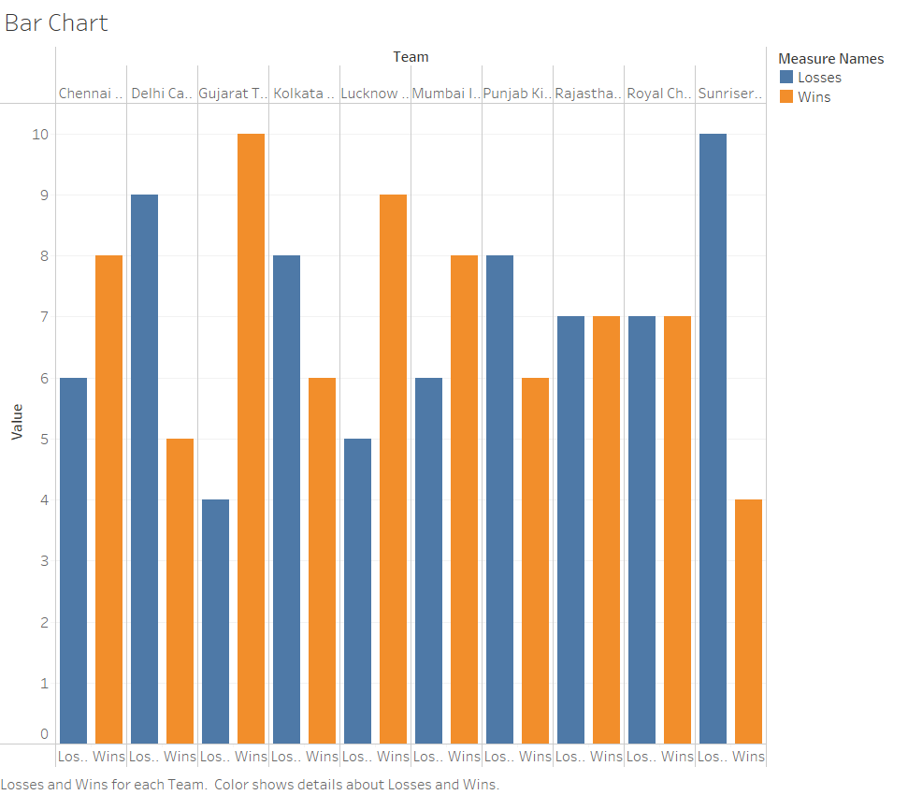

Figure 1: IPL Wins Per Team (Bar Chart)

PIE CHART:

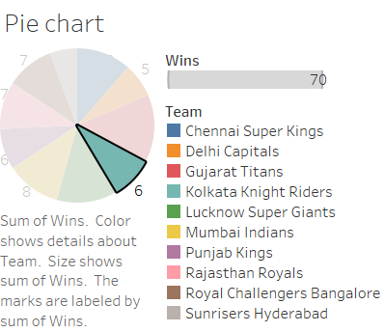

Figure 2: IPL Team Win Distribution (Pie Chart)

SCATTER PLOT:

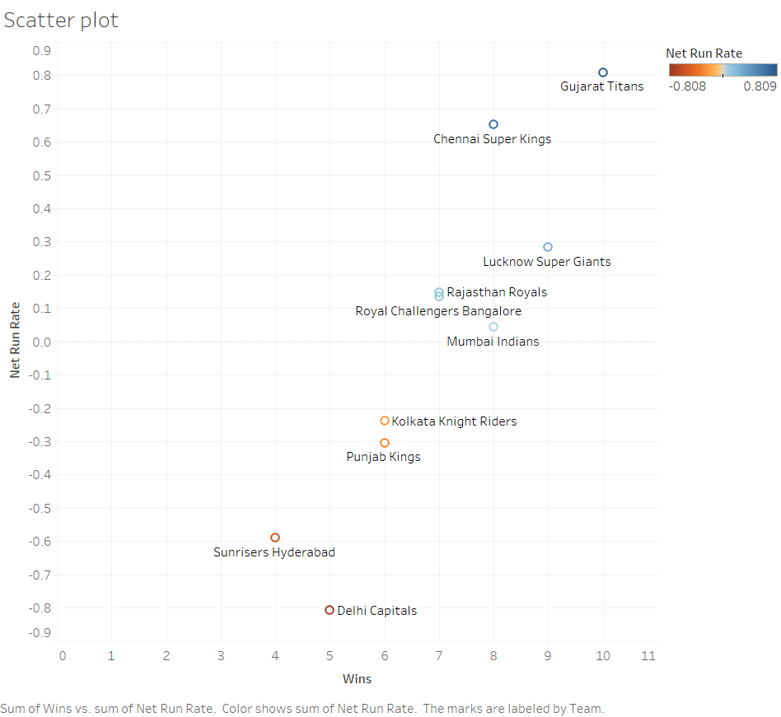

Figure 3: Wins vs. Net Run Rate (Scatter Plot)

HEAP MAP:

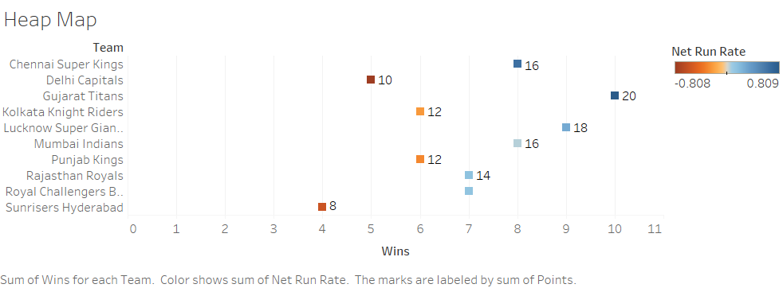

Figure 4: Heatmap of Team Performance

ACKNOWLEDGMENTS

I would like to express my sincere gratitude to my mentor, [Mentor’s Name], for their valuable guidance and support throughout this project. I also extend my thanks to my peers, family, and Tableau community for their insights and feedback.

INTRODUCTION

Background Information:

The Indian Premier League (IPL) is one of the most popular T20 cricket leagues worldwide. Analyzing team performance using data visualization techniques provides valuable insights for fans, analysts, and franchises.

Project Objectives:

* To analyze IPL team performance using Tableau.
* To visualize key performance indicators such as wins, losses, net run rate, and points.
* To create an interactive dashboard for better data interpretation.
* To provide insights for understanding trends and comparisons among IPL teams.

Significance:

This project is important as it helps in understanding IPL trends, improving team strategies, and assisting cricket analysts in making data-driven decisions.

Scope:

This project focuses on IPL team performance analysis using Tableau and excludes individual player analysis and match-by-match breakdowns

Methodology Overview:

A step-by-step process is followed, from data collection to dashboard creation and analysis.

PROBLEM IDENTIFICATION AND ANALYSIS

Description of the Problem:

IPL team performance data is often scattered across multiple sources, making it difficult to analyze trends effectively.

Evidence of the Problem:

Previous IPL analyses have relied on static reports rather than interactive dashboards.

Stakeholders:

* IPL franchises
* Cricket analysts
* Fans and enthusiasts

Supporting Data/Research:

Research papers on sports analytics suggest that data visualization improves decision-making in sports.

SOLUTION DESIGN AND IMPLEMENTATION

Development and Design Process:

* Data Collection: Gather IPL performance data in CSV format.
* Data Cleaning: Prepare data for visualization.
* Dashboard Development: Use Tableau for visual analysis.

Tools and Technologies Used:

* Tableau
* Python (for data cleaning)
* CSV files

Solution Overview:

The interactive dashboard includes bar charts, pie charts, scatter plots, and heatmaps for IPL performance insights.

Engineering Standards Applied:

* Data visualization best practices
* Tableau design principles

RESULTS AND RECOMMENDATIONS

Evaluation of Results:

* The dashboard successfully presents IPL team performance trends and insights.

Challenges Encountered:

* Data cleaning complexity
* Handling missing data

Possible Improvements:

* Adding more filters for in-depth analysis
* Including player-wise performance trends

Recommendations:

* This project can be expanded to include real-time IPL performance tracking.

REFLECTION ON LEARNING AND PERSONAL DEVELOPMENT

Key Learning Outcomes:

* Improved data visualization skills in Tableau
* Hands-on experience with data cleaning and preprocessing

Challenges Encountered and Overcome:

* Overcoming missing data issues
* Improving dashboard performance for large datasets

Application of Engineering Standards:

* Adhered to best practices in data visualization and interactive design.

Insights into the Industry:

* Gained understanding of how data analytics is used in professional cricket.

Conclusion of Personal Development:

* The project enhanced my analytical skills and prepared me for industry-level data visualization projects.

CONCLUSION

This project successfully visualizes IPL team performance using Tableau. The interactive dashboard enables users to analyze team statistics efficiently. The findings can be useful for analysts, sports journalists, and cricket enthusiasts.

REFERENCES

* IPL official website (www.iplt20.com)
* Tableau documentation and tutorials
* Research papers on sports data visualization

APPENDICES

Code Snippets:

* Python scripts for data preprocessing.

Raw Data:

* Sample IPL dataset used for visualization.